Stay in touch with me (
- My Telegram Link
- My Instagram Link
- My Youtube Link
If you are a pirate
This course is officially hosted only in three places:

- On the Udemy website
- On the Stepik website
- On the SkillSpace website

All other sites, platforms, Telegram groups, and similar have obtained and are distributing this course illegally.

Here are some downsides of obtaining this course from unofficial sources:

-You will lose most of the content, as I update and supplement each course monthly. You will already have a 100% outdated version of the course.
-On the official platforms, I answer students' questions every day.
-The price of the course is not high.
-Your conscience will bother you.
-------------------------------------

To use all the features of the textbook, install the Figma application or use its browser version and register on the website.
Link
React JS Interactive Textbook Link
List of VS Code Plugins:
Prettier Formatter,
ESLint,
Material Icon Theme,
All Autocomplete,
Auto Rename Tag,
Color Highlight,
One Monokai Theme,
Live Server,
Snippets:

"Print to console": {
"scope": "javascript, typescript,javascriptreact",
"prefix": "cl",
"body": ["console.log();"],
"description": "Log output to console"
},

"Print const": {
"scope": "javascript,typescript,javascriptreact",
"prefix": "c",
"body": ["const ${1} ="],
"description": "print const"
},

"importCSSModule": {
"prefix": "csm",
"scope": "javascript,typescript,javascriptreact",
"body": ["import styles from './${TM_FILENAME_BASE}.module.css'"],
"description": "Import CSS Module as `styles`"
},

"Print function": {
"scope": "javascript,typescript,javascriptreact",
"prefix": "f",
"body": ["function ${1}(){}"],
"description": "Print function"
},

"reactComponent": {
"prefix": "rfc",
"scope": "javascript,typescript,javascriptreact",
"body": [
"function ${1:${TM_FILENAME_BASE}}() {",
"\treturn (",
"\t\t<div>",
"\t\t\t$0",
"\t\t</div>",
"\t)",
"}",
"",
"export default ${1:${TM_FILENAME_BASE}}",
""
],
"description": "React component"
},
"reactStyledComponent": {
"prefix": "rsc",
"scope": "javascript,typescript,javascriptreact",
"body": [
"import styled from 'styled-components'",
"",
"const Styled${TM_FILENAME_BASE} = styled.$0``",
"",
"function ${TM_FILENAME_BASE}() {",
"\treturn (",
"\t\t<Styled${TM_FILENAME_BASE}>",
"\t\t\t${TM_FILENAME_BASE}",
"\t\t</Styled${TM_FILENAME_BASE}>",
"\t)",
"}",
"",
"export default ${TM_FILENAME_BASE}",
""
],
"description": "React styled component"
}

ES Lint:

Add the rules to the eslint.config.js file in the Vite project:
"no-unused-vars": "warn",
"react/prop-types": "off",
"react/jsx-key": "warn",
// Warning instead of disabling type validation
//"react/prop-types": "warn"

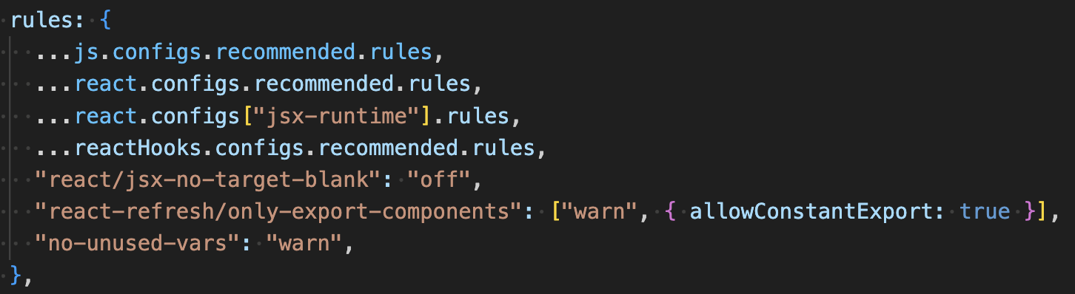

-Public api Link
-Oimdb api Link
-React DevTools Link
-Weather api Link
-Frankfurter API Exchange Currency Link
-JSON Placeholder Link
-Tailwind Link
-Tailwind Prettier Link
-Tailwind Shadows Plugin Link
Setting up JSON Server:
Run the following command to install JSON Server:
npm install json-server
Add the following script to your package.json file:
"scripts": {
"start:api": "json-server --watch data/data.json --port 9000"
}
Then, run the script with:
npm run start:api
API Users https://jsonplaceholder.typicode.com/users
Redux DevTools Extention Link
Vite Imagemin Link

